DR CHANDY & PARTNERS
CHURCH VIEW HEALTH CENTRE

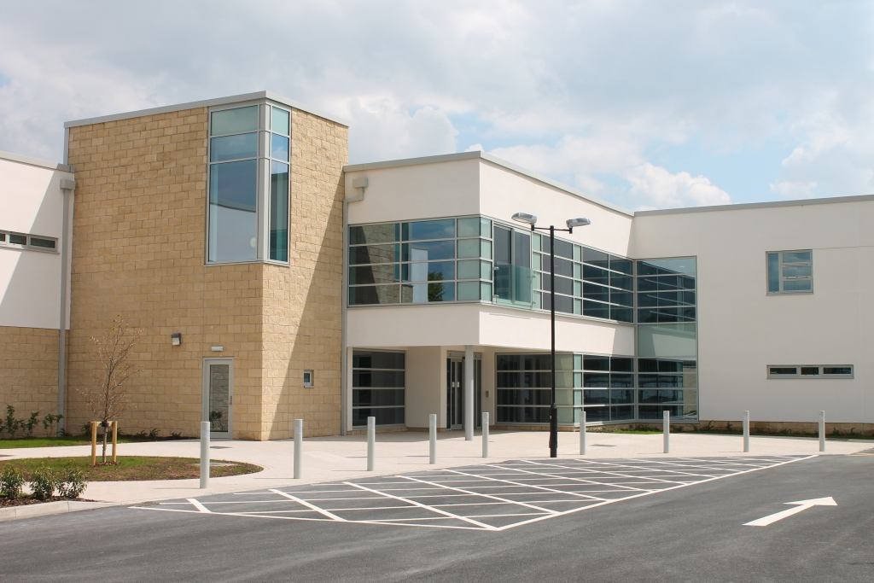

PATIENT PARTICIPATION GROUP
DIRECTED ENHANCED SERVICE 2013/14
REPORT
March 2014

CONTENTS

- Introduction

- Establish a Patient Participation Group

- Agree Priorities and Local Practice Survey

- Collate and Inform Findings of Survey

- Discuss Findings from Patient Survey

- Action Plan and Priorities

- Publicise the Patient Participation Report and Practice Survey

- Appendices

Appendix 1: Terms of Reference
Appendix 2: PPG Recruitment Poster
Appendix 3: Minutes of Patient Participation Group – 9th December 2013
Appendix 4: Patient Survey 2013/14
Appendix 5: Minutes of Patient Participation Group – 10th February 2014

INTRODUCTION

Dr Chandy & Partners at Church View Health Centre is participating in the Patient Participation Direct Enhanced Service (DES) 2013/14. The purpose of the Patient Participation DES is to ensure patients are involved in decisions about the range and quality of services provided and, over time, commissioned by their practice.

The DES aims to promote the proactive engagement of patients through the use of effective Patient Participation Groups and to seek views from the practice’s patients through the use of a Patient Survey.

At the time of writing this report, the practice population was 9201 of which 4717 are male and 4484 are female.

Age Range | Male | Female | Total | Percentage
0-16 | 915 | 813 | 1728 | 19%
17-24 | 517 | 451 | 968 | 10%
25-34 | 620 | 553 | 1173 | 13%
35-44 | 587 | 502 | 1089 | 12%
45-54 | 702 | 661 | 1363 | 15%
55-64 | 592 | 595 | 1187 | 13%
65+ | 784 | 909 | 1693 | 18%
Total | 4717 | 4484 | 9201

The practice has not captured the ethnicity of its entire population but of the 54% of the population it has captured the ethnicity is made up as follows:

White
British | 95%
Irish | 0.7%
Any other white background | 3%

Mixed
White & Black Caribbean | 0.1%
White & Black African | 0.2%
White & Asian | 0.1%
Any other mixed background | 0.1%

Asian or Asia British
Indian | 0.1%
Pakistani | 0.1%
Bangladeshi | 0%
Any other Asian background | 0.1%
Black or Black British
Caribbean | 0.1%
African | 0.1%
Any other black background | 0.1%

Chinese or other ethnic group
Chinese | 0.1%
Any other ethnic group | 0.1%

ESTABLISH A PATIENT PARTICIPATION GROUP

Dr Chandy & Partners initially established a Patient Participation Group (PPG) in September 2008 which consisted of 11 members. The PPG was formed to enable cooperation between practice staff and patients to enable them to work with their practice to provide practical support and to help them take more responsibility for their own health and to provide strategic input and advice.

PPG are good for patients because:

- Patients will be more responsible for their own health.
- Patients will have a better understanding and knowledge of the practice and its staff.
- Patients will be consulted about arrangements for their primary healthcare before decisions are made.
- Patients will benefit from improved communications with staff.
- Patients will have a forum to suggest positive ideas and voice concerns.

PPGs are good for practice staff because:

- GPs and their staff will be able to plan services jointly with patients in order to increase their effectiveness.
- They will be able to help patients with non-medical and social care issues.
- They will be able to get help from patients in meeting targets and objectives.
- They will have a forum to voice concerns, ideas and suggestions to patients.
- They will get closer to the community for whom they care.

The Practice is also a current and active member of National Association of Patient Participation (NAPP).

The PPG members from the initial group established in 2008 were very active during the consultation phase and building stage of the practice’s new premises (Church View Health Centre) which opened in May 2013. However, regular and structured meetings were not maintained by the practice. It was decided in 2013, after the opening of the new surgery, that all the members of the initial PPG would be contacted to ascertain their interest to continue participating in the group. We were delighted that 8 members expressed their interest to continue.

The current PPG consists of 8 members. There are 7 male representatives and 1 female representative. The ethnicity of the group is 100% White British. The age profile is:

3 x members: 55-64
5 x members: 65+

Representation on the PPG from the practice are Jill Taylor, Practice Manger, Dr Bidisha Buckham, GP Partner and Dr Alex Thachankary, GP Partner.

It has been decided by the group that meetings will be held every 3 months alternating between evening and day time meetings to ensure that all group members have an opportunity to attend if they are not available due to work or social commitments to attend in the day or evening. Terms of Reference are included in Appendix 1 of this report.

It is recognised that the current group is not entirely representative of the practice population but there is expertise and interest within the group from the disabled community. The pre-existing PPG only has 8 members and it was felt that the group should consist of 12 members. Therefore, it was decided to undertake a campaign to attract more patients to the group. This campaign commenced in December 2013.

Key practice demographics which will be considered in the make-up of the PPG will relate to, but not confined to:

- Age
- Ethnicity
- Gender
- Parental Status
- Disabled Status
- Carer Status
- Socio-economic group
- Long-Term condition patients
- Patients with specific care needs, e.g., drug users, learning difficulties, housebound, etc.

The methods used to invite patients to be members of the PPG included:

- Practice website
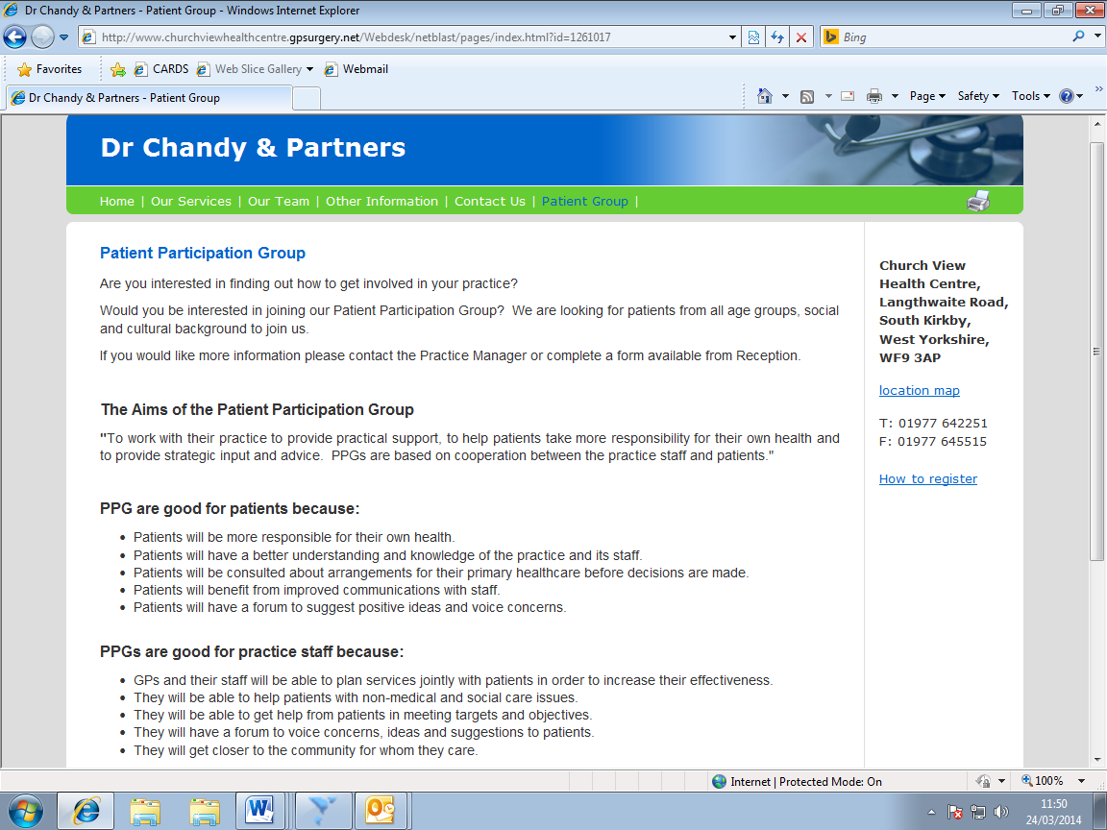

- Practice LCD “Power Point” presentation display screen.
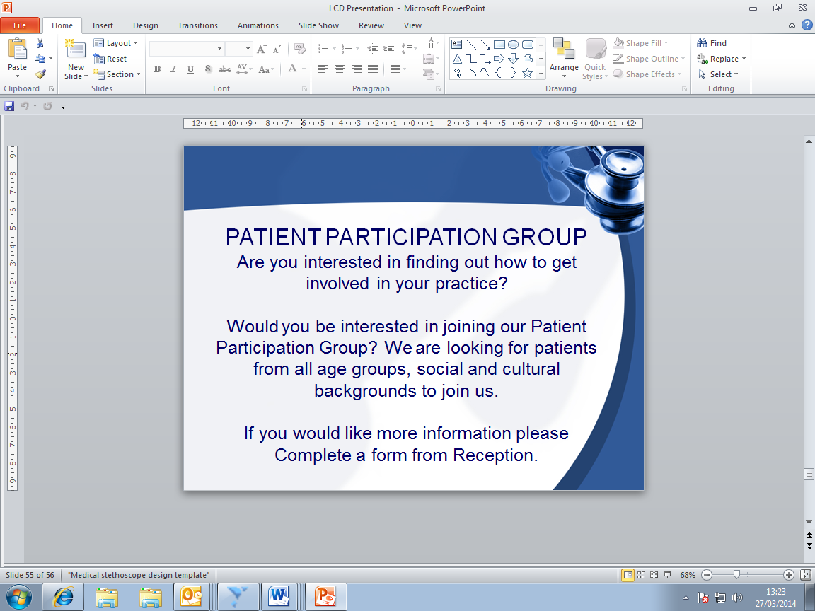

- Poster and leaflets in the clinical rooms (including rooms used by Midwife and Baby Immunisation Clinic to encourage young mothers), reception and around the surgery to attract a wide range of the population (Appendix 2).
- Notes on the bottom of repeat prescriptions.
- All new patients registering with the practice receiving a leaflet within the New Patient Pack.
- Leaflets in Carers’ pack/information.
- Word of mouth by clinicians and staff when patients are in surgery.

Patients register their interest by completing a form which is available from the reception or contacting the Practice Manager directly. The Practice Manager will discuss with any interested patient the aims and objectives of the group.

AGREE PRIORITIES AND LOCAL PRACTICE SURVEY

In the PPG meeting held on 9th December 2013 (Appendix 3) the proposed Patient Survey was reviewed and discussed. The Practice Survey is based on the suggested model for the DES. Although this is a lengthy survey, it was felt it needed to be comprehensive as it is the first Patient Survey to be undertaken in the new surgery. Also it was felt that the comprehensive questions address key areas such as reception, appointments, access, communication, continuity and enablement as well as fulfilling some of the Essential Standards and Outcomes required for our Registration and Regulation by the Care Quality Commission (CQC), i.e., Respecting and Involving People Who Use Services; Safety and Suitability of Premises and Assessing and Monitoring the Quality of Service Provision. It was also agreed that as it was the first Patient Survey in the new surgery some additional questions should be added relating to the surgery experience. It was agreed to add questions about getting to the surgery/transport, what services patients would like to see in the new surgery and feedback on signage in the building. The Patient Survey is attached as Appendix 4.

It was agreed that the Patient Survey would be undertaken in January 2014. The practice was required to obtain 25 responses per 1000 head of population. Based on a patient population of approximately 9200 patients, 250 questionnaires were distributed. This represents 2.7% of the population.

The Patient Survey was undertaken for a period of 2 weeks in January 2014. A total of 250 paper questionnaires were distributed to patients seeing doctors, the advanced nurse practitioner, nurses and healthcare assistants. Those participating in the survey did so anonymously under the instruction to complete the survey after the consultation based on the events prior to and during the consultation. Patients were encouraged to complete the survey whilst they were at the surgery. A sealed box was place on the Reception Desk in the Waiting Room to deposit completed surveys. The box was emptied and surveys processed daily by the Practice Manager.

COLLATE AND INFORM FINDINGS OF SURVEY

A total of 250 Patient Surveys were distributed and 240 were completed. This represents 2.6% of the population. Of the completed Patient Surveys, 36% were returned by male patients and 64% by female patients. The ethnicity mix was 99% “White British” and 1% “Any Other White Background”. There were no completed Patient Surveys from any other ethnic group. The age distribution was as follows:

Under 18 | 2%
18-24 | 4%
25-34 | 16%
35-44 | 11%
45-54 | 28%
55-64 | 16%
65-74 | 15%
75-84 | 7%
85 and over | 1%

The completed Patient Surveys were collated and analysed by the Practice Manager and the results formatted indicating responses in percentage terms for ease of review (outlined below). All Patient Surveys have been kept for reasons of probity.

The practice are delighted with the volume of the response and cooperation we have received from participants and feel it is important to tell you the results of the Patient Survey and our Action Plan.

The results were discussed in detail at a meeting on 10th February 2014 (Appendix 5), which enabled the practice and the PPG to discuss, agree and approve an Action Plan based upon the results and findings. The results were also shared with practice staff in a Staff Meeting on 12th February 2014.

This document will be available on our Practice Website (www.churchviewhealthcentre.gpsurgery.net) and the results of the Patient Survey in Pie Chart format displayed on the internal LCD “Power-Point” presentation display screen in the waiting room.

Patients were asked a total of 27 questions with regards to:

- Appointments at the surgery
- Getting through on the phone
- Seeing a doctor
- Arriving for your appointment
- Seeing the doctor you prefer
- Opening hours
- Seeing a doctor at the surgery
- Seeing a practice nurse at the surgery
- Overall satisfaction

The results in percentage format our outlined below:

A | Appointments at the Surgery

Q1: When did you last see a doctor at the surgery?
In the past 3 months | 66%
Between 3 and 6 months ago | 15%
More than 6 months ago | 18%
I have never been seen at the surgery before | 1%

Q2: If you haven’t seen a doctor in the past 6 months, why is that?
I haven’t needed to see a doctor | 70%
I couldn’t be seen at a convenient time | 5%
I couldn’t get to my appointment easily | 11%
I didn’t like or trust the doctors | 3%
Another reason | 11%

B | Getting through on the phone

Q3: In the past 6 months how easy have you found the following?
 | Haven’t tried | Very  Easy | Fairly  Easy | Not very easy | Not at all easy | Don’t know
Getting through on the phone | 6% | 38% | 42% | 12% | 1% | 1%
Speaking to a doctor on the phone | 50% | 8% | 14% | 2% | 2% | 24%
Speaking to a nurse on the phone | 45% | 18% | 12% | 2% | 0% | 23%
Obtaining test results by phone | 35% | 20% | 23% | 5% | 0% | 17%

C | Seeing a Doctor

Q4: In the past 6 months have you tried to see a Doctor fairly quickly?
Yes | 67%
No | 29%
Can’t remember | 4%

Q5: Think about the last time you tried to see a doctor fairly quickly. Were you able to see a doctor on the same day or in the next two weekdays that the surgery was open?
Yes | 74%
No | 19%
Can’t remember | 7%

Q6: If you weren’t able to be seen during the next 2 weekdays that the surgery was open, why was that?
There weren’t any appointments | 40%
Times offered didn’t suit | 11%
Appointment was with a doctor who I didn’t want to see | 4%
A nurse was free but I wanted to see a doctor | 4%
Another reason | 9%
Can’t remember | 32%

Q7: In the past 6 months, have you tried to book ahead for an appointment with a Doctor?
Yes | 54%
No | 41%
Can’t remember | 5%

Q8: Last time you tried, were you able to get an appointment with a Doctor more than 2 weekdays in advance?
Yes | 47%
No | 39%
Can’t remember | 14%

D | Arriving for your appointment

Q9: How did you get to the surgery today?
Walked | 15%
Car | 80%
Taxi | 2%
Bus | 1%
Other | 2%
Q10: How easy do you find getting to the surgery?
Very easy | 77%
Fairly easy | 19%
Not very easy | 2%
Not at all easy | 2%

Q11: How easy to understand is the signage in the surgery/building?
Very easy | 79%
Fairly easy | 17%
Not very easy | 3%
Not at all easy | 1%

Q12: How clean is the surgery?
Very clean | 93%
Fairly clean | 7%
Not very clean | 0%
Not at all clean | 0%
Don’t know | 0%

Q13: In the Reception Area, can other patients overhear what you say to the Receptionist?
Yes, but don’t mind | 58%
Yes and am not happy about it | 21%
No, other patients can’t overhear | 7%
Don’t know | 14%

Q14: How helpful do you find the receptionists at the Surgery?
Very | 79%
Fairly | 20%
Not very | 1%
Not at all | 0%

Q15: How long after your appointment time do you normally wait to be seen?
I am normally seen on time | 16%
Less than 5 minutes | 16%
5-15 minutes | 42%
15-30 minutes | 16%
More than 30 minutes | 7%
Can’t remember | 3%

Q16: How do you feel about how long you normally have to wait?
I don’t normally have to wait long | 65%
I have to wait a bit too long | 20%
I have to wait far too long | 8%
No opinion/doesn’t apply | 7%

E | Seeing the Doctor you prefer

Q17: Is there a particular Doctor you prefer to see at the Surgery?
Yes | 67%
No | 33%

Q18: How often do you see the Doctor you prefer?
Always or most of the time | 51%
A lot of the time | 18%
Some of the time | 29%
Never or almost never | 2%

F | Opening Hours

Q19: How satisfied are you with the opening hours at the surgery?
Very | 57%
Fairly | 30%
Neither satisfied nor dissatisfied | 5%
Quite dissatisfied | 2%
Very dissatisfied | 1%
Don’t know opening hours | 5%

Q20: Would you like the surgery open at additional times?
Yes | 26%
No | 74%
If Yes please state:
Evening Surgery
Early Morning Surgery
Weekends

G | Seeing a Doctor at the Surgery

Q21: The last time you saw a Doctor at the Surgery how good was the Doctor at each of the following?
 | Very good | Good | Neither good nor poor | Poor | Very poor | Doesn’t apply
Giving you enough time | 53% | 38% | 4% | 3% | 1% | 1%
Asking about your symptoms | 52% | 41% | 3% | 2% | 0% | 2%
Listening | 54% | 37% | 6% | 2% | 0% | 1%
Explaining tests and treatments | 53% | 36% | 4% | 1% | 0% | 6%
Involving you in decisions about your care | 52% | 34% | 5% | 3% | 0% | 6%
Treating you with care and concern | 53% | 37% | 4% | 4% | 0% | 2%
Taking your problems seriously | 54% | 34% | 6% | 3% | 1% | 2%

Q22: Did you have confidence and trust in the doctor you saw?
Yes, definitely | 74%
Yes, to some extent | 23%
No, not at all | 1%
Don’t know/can’t say | 2%

H | Seeing a Practice Nurse at the Surgery

Q23: How easy is it for you to get an appointment with a Practice Nurse at the Surgery?
Haven’t tried | 25%
Very | 46%
Fairly | 23%
Not very | 1%
Not at all | 1%
Don’t know | 4%

Q24: The last time you saw a Practice Nurse at the Surgery how good was the Practice Nurse at each of the following?
 | Very good | Good | Neither good nor poor | Poor | Very poor | Doesn’t apply
Giving you enough time | 61% | 27% | 1% | 0% | 0% | 11%
Asking about your symptoms | 57% | 27% | 2% | 1% | 0% | 13%
Listening | 60% | 26% | 2% | 0% | 0% | 12%
Explaining tests and treatments | 55% | 26% | 1% | 1% | 5% | 12%
Involving you in decisions about your care | 53% | 29% | 2% | 2% | 0% | 14%
Treating you with care and concern | 58% | 25% | 2% | 1% | 0% | 14%
Taking your problems seriously | 58% | 24% | 3% | 1% | 0% | 14%

I | Your Overall Satisfaction

Q25: In general, how satisfied are you with the care you get at the Surgery?
Very | 73%
Fairly | 24%
Neither satisfied nor dissatisfied | 2%
Quite dissatisfied | 1%
Very dissatisfied | 0%

Q26: Would you recommend the Surgery to someone who has just moved to the area?
Yes | 84%
Might | 8%
Not sure | 4%
Probably not | 2%
Definitely not | 1%
Don’t know | 1%

Q27: Do you know the surgery hosts/provides additional services and clinics to GP and Nurse appointments?
Yes | 42%
No | 58%

Q28: What other services would you like to see at the surgery?
Please State: Gym; Minor Surgery; Dental; Weight Loss Clinic; MRI Scanning; Ultra-Sound, X-Ray; Minor Injuries; Hearing Clinic.

DISCUSS FINDINGS FROM PATIENT SURVEY

The survey findings were discussed at the Patient Participation Group Meeting held on 10th February 2014 (Appendix 5). The overview of the collated survey circulated at the meeting clearly demonstrated areas where the practice had scored well and also those areas where improvement might be needed. This enabled the practice and the PPG to agree and approve an Action Plan based upon the results and findings. Overall, however, the PPG felt that the results were very good and encouraging.

ACTION PLAN AND PRIORITIES

Having discussed the findings of the survey, the PPG agreed the following Action Plan based on the results and areas where it felt there could be improvement.

Area | Obtaining test results by phone
Recommendation | To utilise through the clinical system (SystmOne) the ability to send test results by SMS text message. The practice has been utilising the system of confirming appointments by sending reminders by SMS text for about a year and this has worked well. It was felt that a test result SMS text system would be an enhancement to our service and ease the phone lines of people telephoning for test results.
Action | Investigate via the clinical system and with the SystmOne User Group how to activate this. Promotion of this service will need to be undertaken in the surgery and consent obtained from patients who wish to utilise this service.
Lead | Jill Taylor
Timeframe | End of April 2014
Comments | Feedback progress at next PPG Meeting in 7th April 2014

Area | Promotion of current services
Recommendation | Promote all the services currently carried out within the practice. Patient Survey feedback revealed that 58% of patients do not know what additional services the surgery hosts (Q27) and those who stated what services they would like to see some were already provided (Q28).
Action | Promote all services within the clinic via the Practice Website, LCD “Power-Point” presentation display screen and posters in surgery.
Lead | Jill Taylor
Timeframe | By the end of March 2014
Comments | Achieved

Area | Patient Confidentiality
Recommendation | Advertise that a private room is available for patients to discuss issues in a more confidential setting when they are at the Reception Desk. Q13 of the Patient Survey revealed that 21% of patients were not happy about being overheard when at the Reception Desk.
Action | Put sign up on Reception Desk advising patients that if they wish to have a discussion in a more confidential setting then they can request to use the Interview Room adjacent to the Reception.
Lead | Jill Taylor
Timeframe | By the end of February 2014
Comments | Achieved

Area | Opening times
Recommendation | Promote the opening times and extended hours opening times within the surgery. The Patient Survey revealed that some patients do not know the surgery is open two late nights per week until 9pm.
Action | Promote opening times within the clinic via the Practice Website, LCD “Power-Point” presentation display screen and posters in surgery.
Lead | Jill Taylor
Timeframe | By the end of March 2014
Comments | Achieved

Area | Survey results
Recommendation | To promote the Patient Survey results
Action | Display the results on the practice Notice Board in colour graph format and on the LCD “Power-Point” Presentation Display Screen. Post DES Report on Practice Website.
Lead | Jill Taylor
Timeframe | By the end of March 2014
Comments | Achieved

PUBLICISE THE PATIENT PARTICIPATION REPORT AND PRACTICE SURVEY

This report has been uploaded on to our Practice Website www.churchviewhealthcentre.gpsurgery.net

Appendix 1:

TERMS OF REFERENCE

Introduction:

The key role of the group is to bring together patients, doctors and members of the practice team to work in partnership in order to promote the wellbeing of patients and support the practice to provide a high quality of care and service delivery.

Membership:

Appointment to the group will be considered and approved by existing members.

Chairing the Meetings:

The current Chair of the group is the Practice Manager. The group have decided that following the recruitment of additional members to agreed maximum of 12 then the Chair position will be shared on a meeting-by-meeting basis. The Chair for the following meeting will be agreed at the end of each meeting.

In the event of the Chair’s absence, another group member will be asked to Chair the group.

Arrangements for the Conduct of Business:

- Quorum – Quorum for the PPG constitutes a minimum of 6 members attending with no less than 6 representatives. If minimum attendance is not met, the meeting will be re-scheduled.

- Frequency of Meetings – PPG will normally expect to meet at least 4 times per year with the option of additional extraordinary meetings to address specific issues.

- Members are required to declare any interest that may conflict with their role in the group. If any member is unclear about conflicting interest, they should declare this and seek further guidance.

- It would be appreciated if members could commit to attending 50% of meetings as a minimum expectation.

- It would be useful if group members read all information that is given to them before the meeting and prepare any questions/issues they wish to raise.

- All group members must be willing to undertake work if asked by the PPG e.g. help conduct surveys, assist with CQC inspections.

- Send apologies if you are unable to attend the meeting.

- Only one person to speak at a time.

- Treat each other with respect even if you do not agree with things that are being said. Challenge politely.

- Mobile phones – switch to Silent Mode/turn off.

- All members of the group will be contacted in advance and invited to raise items to be placed on the agenda.

- Stick to the agenda.

- Meeting is not to talk about individuals but issues raised.

- Everyone must respect confidentiality. Sometimes we must decide not to write things down or tell other people about what we have heard.

- If someone is bad mannered/rude, they can be asked to leave the meeting.

- If someone can no longer commit to the PPG, they must inform the practice.

Roles and Functions:

- Act as a planning tool – can be consulted on service development and provision.

- Provide feedback on patients’ needs, concerns and interests.

- Feedback information from the community, in general, which may affect healthcare.

- Give patients a voice in the organisation of their care.

- Give feedback to NHS Trusts on consultations.

- Liaise with other Patient Participation Groups in the area.

- Will not act as a forum for discussion of personal or health-related complaints against the Practice.

Relationships and Reporting:

- Minutes of meetings will be taken by the Practice Manager.

- Practice Manager/GP or representative will be invited to attend all PPG meetings.

Review of Terms of Reference:

These Terms of Reference will be reviewed upon successful recruitment of additional PPG members to a maximum of 12 and thereafter annually.

Appendix 2:

CHURCH VIEW HEALTH CENTRE
PATIENT PARTICIPATION GROUP

Are you interested in finding out how to get involved in your practice?

Would you be interested in joining our Patient Participation Group? We are looking for patients from all age groups, social and cultural backgrounds to join us.

If you would like more information please complete a form from Reception and the Practice Manager will contact you.

Appendix 3

DR CHANDY & PARTNERS

CHURCH VIEW HEALTH CENTRE

MINUTES OF THE MEETING
of the Patient Participation Group
Held on Monday, 9th December 2013 at 6.30pm
In the Community Room at Church View Health Centre

Present

Practice Representation:
Jill Taylor, Practice Manager
Bidisha Buckham, GP Partner
Dr Alex Thachankary, GP Partner
Patient Participation Group:
PS; MR; DR; TS; AB

Apologies

DS; SB; JF

- Welcome

Dr Buckham said it was with great pleasure to finally welcome the Patient Participation Group to Church View Surgery and thanked those present for coming to the first meeting at the new surgery. It was acknowledged that it had been a long time since the last meeting but it was good to see members at the Turf Cutting Ceremony and for the support shown during the planning and building phase. Certainly we could not have achieved the new surgery without continued support and commitment from our patients.

- Apologies

Apologies were received from DS, SB and JF.

- Building Update

Dr Buckham gave an update on the services within the new surgery. The Ground Floor is occupied by Mid Yorks NHS Trust and houses the health visitors, district nurses, and clinics for warfarin, podiatry, diabetic dietician, sexual health and retinal screening. Community Dentistry, previously at South Elmsall Surgery, will be moving in on 6th January and the NHS Dentist, Nationwide Dental Care currently in South Elmsall will also move in during the early part of the New Year.

The practice is hosting various services including physiotherapy, audiology, ultrasound, dietician, Right Steps (Counselling), Health Trainers, minor surgery and contraceptive services.

Dr Buckham also welcomed any suggestions on how we could utilise the Community Space. This will be discussed at the next meeting.

It was reported that overall the feedback from patients about the new surgery had been very positive. There had been some minor complaints about internal and external signage. The internal signage is currently being addressed and the Highway Department has now put a sign on the main road following a request from the practice.

The practice is also currently liaising with Langthwaite Business Park to ascertain if any of the businesses on the Park feel it would benefit their non-driving employees to have some of the bus routes come on to the Business Park. It was proposed that Arriva Buses could be contacted if enough businesses felt this was a good idea.

All present at the meeting were pleased with the new surgery which was encouraging. The practice is always looking for improvements and suggestions and these will be addressed thorough the Patient Group.

- 2013/14 Patient Questionnaire

Jill Taylor (JT) distributed a copy of the forthcoming patient survey which will be undertaken in January 2014. As this is the first patient survey in the new surgery it was proposed that this was a good opportunity to add on some specific questions relating to the surgery experience. It was agreed to add questions about getting to the surgery/transport, what new services patients would like to see in the new surgery and feedback on signage in the building.
- The Care Quality Commission

JT advised the Group that from April 2013 the surgery had been registered and regulated by the Care Quality Commission (CQC). The CQC check services to make sure they meet the national standards of quality and safety. The surgery may be subject to a scheduled inspection at any time, as other GP practices in Wakefield have been inspected over the last few months.

The CQC during the inspections like to meet and engage with the Patient Participation Group as they are a valuable source of information about patients’ views and experiences. JT distributed to the members present a CCQ publication “A Guide for Working Together – The CQC and Patient Participation Groups” which outlines a bit more information about their role. JT asked if the practice was advised of a visit, which is usually 3 days’ notice, if any of the members would be happy to meet with them during the inspection. All those present said they would be happy to do this if they were available on inspection day.

- Recruitment of New PPG Members

The PPG currently has 8 members. It was felt that approximately 12 members would be suitable for the size of the practice. It was proposed that during January a recruitment campaign for new members would be advertised. Feedback from this would be discussed at the next meeting.

- Future Meetings

It was suggested going forward that we should meet every 3 months. To ensure that all the Group have an opportunity to attend the meetings it was proposed that these would alternate between day time and evening meetings. This was agreed by those present.

- Any Other Business

Dr Buckham advised the Group that Dr J Chandy, Senior Partner was retiring at the end of March 2014. The practice would be renamed Dr Singh & Partners.

- Date of Next Meeting

It was agreed that the next meeting would be on Monday, 10th February 2014 at 6.30pm.

Appendix 4:
DR CHANDY & PARTNERS
CHURCH VIEW HEALTH CENTRE
PATIENT SURVEY 2013/14
A | Appointments at the Surgery

Q1: When did you last see a doctor at the surgery?
In the past 3 months
Between 3 and 6 months ago
More than 6 months ago
I have never been seen at the surgery before

Q2: If you haven’t seen a doctor in the past 6 months, why is that? Please tick all the boxes that apply.
I haven’t needed to see a doctor
I couldn’t be seen at a convenient time
I couldn’t get to my appointment easily
I didn’t like or trust the doctors
Another reason

B | Getting through on the phone

Q3: In the past 6 months how easy have you found the following? Please put a tick in one box for each row
 | Haven’t tried | Very  Easy | Fairly  Easy | Not very easy | Not at all easy | Don’t know
Getting through on the phone
Speaking to a doctor on the phone
Speaking to a nurse on the phone
Obtaining test results by phone

C | Seeing a Doctor

Q4: In the past 6 months have you tried to see a Doctor fairly quickly? By fairly quickly we mean on the same day or in the next two weekdays that the surgery was open.
Yes
No
Can’t remember
Q5: Think about the last time you tried to see a doctor fairly quickly. Were you able to see a doctor on the same day or in the next two weekdays that the surgery was open?
Yes
No
Can’t remember

Q6: If you weren’t able to be seen during the next 2 weekdays that the surgery was open, why was that? Please tick all the boxes that apply
There weren’t any appointments
Times offered didn’t suit
Appointment was with a doctor who I didn’t want to see
A nurse was free but I wanted to see a doctor
Another reason
Can’t remember

Q7: In the past 6 months, have you tried to book ahead for an appointment with a Doctor? By ‘booking ahead’ we mean booking an appointment more than two weekdays in advance.
Yes
No
Can’t remember

Q8: Last time you tried, were you able to get an appointment with a Doctor more than 2 weekdays in advance?
Yes
No
Can’t remember

D | Arriving for your appointment

Q9: How did you get to the surgery today?
Walked
Car
Taxi
Bus
Other

Q10: How easy do you find getting to the surgery?
Very easy
Fairly easy
Not very easy
Not at all easy
Q11: How easy to understand is the signage in the surgery/building?
Very easy
Fairly easy
Not very easy
Not at all easy

Q12: How clean is the surgery?
Very clean
Fairly clean
Not very clean
Not at all clean
Don’t know

Q13: In the Reception Area, can other patients overhear what you say to the Receptionist?
Yes, but don’t mind
Yes and am not happy about it
No, other patients can’t overhear
Don’t know

Q14: How helpful do you find the receptionists at the Surgery?
Very
Fairly
Not very
Not at all

Q15: How long after your appointment time do you normally wait to be seen?
I am normally seen on time
Less than 5 minutes
5-15 minutes
15-30 minutes
More than 30 minutes
Can’t remember

Q16: How do you feel about how long you normally have to wait?
I don’t normally have to wait long
I have to wait a bit too long
I have to wait far too long
No opinion/doesn’t apply

E | Seeing the Doctor you prefer

Q17: Is there a particular Doctor you prefer to see at the Surgery?
Yes
No

Q18: How often do you see the Doctor you prefer?
Always or most of the time
A lot of the time
Some of the time
Never or almost never

F | Opening Hours

Q19: How satisfied are you with the opening hours at the surgery?
Very
Fairly
Neither satisfied nor dissatisfied
Quite dissatisfied
Very dissatisfied
Don’t know opening hours

Q20: Would you like the surgery open at additional times?
Yes
No
If yes please state:

G | Seeing a Doctor at the Surgery

Q21: The last time you saw a Doctor at the Surgery how good was the Doctor at each of the following? Please put a tick in one box for each row
 | Very good | Good | Neither good nor poor | Poor | Very poor | Doesn’t apply
Giving you enough time
Asking about your symptoms

Listening
Explaining tests and treatments
Involving you in decisions about your care
Treating you with care and concern
Taking your problems seriously

Q22: Did you have confidence and trust in the doctor you saw?
Yes, definitely
Yes, to some extent
No, not at all
Don’t know/can’t say

H | Seeing a Practice Nurse at the Surgery

Q23: How easy is it for you to get an appointment with a Practice Nurse at the Surgery?
Haven’t tried
Very
Fairly
Not very
Not at all
Don’t know

Q24: The last time you saw a Practice Nurse at the Surgery how good was the Practice Nurse at each of the following? Please put a tick in one box for each row
 | Very good | Good | Neither good nor poor | Poor | Very poor | Doesn’t apply
Giving you enough time
Asking about your symptoms

Listening
Explaining tests and treatments
Involving you in decisions about your care
Treating you with care and concern
Taking your problems seriously

I | Your Overall Satisfaction

Q25: In general, how satisfied are you with the care you get at the Surgery?
Very
Fairly
Neither satisfied nor dissatisfied
Quite dissatisfied
Very dissatisfied

Q26: Would you recommend the Surgery to someone who has just moved to the area?
Yes
Might
Not sure
Probably not
Definitely not
Don’t know

Q27: Do you know the surgery hosts/provides additional services and clinics to GP and Nurse appointments?
Yes
No
If yes please state which services you know:

Q28: What other services would you like to see at the surgery?
Please State:______________________________________________________
_________________________________________________________________
_________________________________________________________________
_________________________________________________________________
J | Some questions about you

The following questions will help us to see how experiences vary between different groups of the population.

Q29: Are you male or female?
Male
Female

Q30: How old are you?
Under 18
18-24
25-34
35-44
45-54
55-64
65-74
75-84
85 and over

Q31: Which of these best describes what you are doing at present? If more than one of these applies to you, please tick the main one ONLY
Full-time paid work (30 hrs or more per week)
Part-time paid work (under 30 hrs per week)
Full-time education (school, college, university)
Unemployed
Permanently sick or disabled
Fully retired from work
Looking after the home
Doing something else

Q32: What is your ethnic group? Chose one section from A to E below, then select the appropriate option to indicate your ethnic group

- White
British
Irish
Any other white background
B. Mixed
White & Black Caribbean
White & Black African
White & Asian
Any other mixed background

C. Asian or Asia British
Indian
Pakistani
Bangladeshi
Any other Asian background

D. Black or Black British
Caribbean
African
Any other black background

E. Chinese or other ethnic group
Chinese
Any other ethnic group

Q33 Which doctor did you see today? Please tick

Dr J Chandy [ ]
Dr S Singh [ ]
Dr Alex Thachankary [ ]
Dr B Buckham [ ]
Dr A Schlesinger [ ]
Dr A Hamal [ ]
ANP/Nurse/HCA [

Appendix 5:

DR CHANDY & PARTNERS
CHURCH VIEW HEALTH CENTRE

MINUTES OF THE MEETING
of the Patient Participation Group
Held on Monday, 10th February 2014 at 6.30pm
In the Community Room at Church View Health Centre

Present

Jill Taylor, Practice Manager, Chair
MR
DR
AB
JF
TS

Apologies

Dr Bidisha Buckham, GP Partner
Dr Alex Thachankary, GP Partner
PS
DS
SB

1. Minutes of the Last Meeting

The Minutes of the Meeting held on 9th December 2013 were distributed prior to the meeting. JT went through the Minutes and they were accepted as being a true record of the meeting.

2. 2013-14 Patient Survey Feedback

JT reported that the practice had run a Patient Survey for a 2-week period in January 2014. A total of 250 paper surveys were distributed to patients seeing doctors, the advanced nurse practitioner, nurses and healthcare assistants during this time. Those participating in the survey did so anonymously under the instruction to complete the survey after the consultation based on the events prior to and during the consultation. Patients were encouraged to complete the surveys whilst they were at the surgery. A sealed box was placed on the Reception Desk in the Waiting Room to deposit completed surveys. The box was emptied and surveys processed daily by the Practice Manager. All patient surveys have been kept for reasons of probity.

240 completed surveys were returned. It was agreed by the PPG that this was an excellent take-up.

JT summarised that of the 240 surveys returned, 36% were returned by male patients and 64% by female patients. The ethnicity mix was 99% “White British” and 1% “Any Other White Background”. There were no completed surveys from any other ethnic group. The age distribution was as follows:

Under 18 | 2%
18-24 | 4%
25-34 | 16%
35-44 | 11%
45-54 | 28%
55-64 | 16%
65-74 | 15%
75-84 | 7%
85 and over | 1%

JT distributed an overview of the outcome of the survey in percentage format for review by the PPG. The overview clearly displayed areas where the practice had scored well and also those areas where improvement might be needed. This enabled the practice and the PPG to agree and approve an Action Plan based upon the results and findings.

Overall the PPG felt that the results were very good and encouraging. In particular, comment was made about positive feedback on the following questions:

- Q3: Getting through on the phone: 38% found this “Very Easy” and 42% “Fairly Easy”. This was encouraging and an indication that the new phone system and process of answering incoming telephone calls was improving.

- Q5: Were you able to see a doctor on the same day or the next two weekdays?: 74% answered “Yes”. This is very encouraging about access to appointments at the surgery.

- Q19: How satisfied are you with the opening hours at the surgery?: 57% responded “Very” and 30% responded “Fairly”. It was discussed that 74% answered “No” to the question “Would you like the surgery open at additional times?” However, of the 26% who said “Yes” some responses indicated they would like an evening surgery. As the surgery already operates two late night doctor and nurse clinics until 9pm at Church View and the branch surgery at Hemsworth, this will be added to the Action Plan to promote these more.

- Q26: Would you recommend the surgery to someone who has just moved to the area?: 84% responded that they would.

Of the additional questions added to the survey following the PPG meeting on 9th December 2013, the following responses were collated:

- Q10: How easy do you find getting to the surgery?: 77% responded “Very Easy” and 19% “Fairly Easy”. Of these, 80% come to the surgery by car, 15% walked, 2% by taxi and 1% bus. This was very encouraging as it had been a concern at the time of the public consultation prior to the new surgery being built that the re-location of the surgery would prove difficult for some patients.

- Q11: How easy is it to understand the signage in the surgery?: 79% said “Very Easy” and 17% “Fairly Easy”. This was also encouraging as initially upon opening of the new surgery some patients had commented that the signage was confusing or inadequate. Extra signage was put in place at that time and it would appear now that the majority of patients find the signage sufficient and easy to follow.

- Q28: What new services would you like to see at the surgery?: Responses included gym, minor surgery, dental, weight loss clinic, MRI Scanning, X-ray, ultrasound, minor injuries, hearing clinic. It was discussed that some of these services are already being provided so this will be added to the Action Plan with a recommendation to promote the services currently provided.

4. Patient Survey Action Plan

Having discussed the findings of the survey the following Action Plan was agreed:

Area | Obtaining test results by phone
Recommendation | To utilise through the clinical system (SystmOne) the ability to send test results by SMS text message. The practice has been utilising the system of confirming appointments by sending reminders by SMS text for about a year and this has worked well. It was felt that a test result SMS text system would be an enhancement to our service and ease the phone lines of people telephoning for test results.
Action | Investigate via the clinical system and with the SystmOne User Group how to activate this. Promotion of this service will need to be undertaken in the surgery and consent obtained from patients who wish to utilise this service.
Lead | Jill Taylor
Timeframe | End of April 2014
Comments | Feedback progress at next PPG Meeting in 7th April 2014

Area | Promotion of current services
Recommendation | Promote all the services currently carried out within the practice. Patient Survey feedback revealed that 58% of patients do not know what additional services the surgery hosts (Q27) and those who stated what services they would like to see some were already provided (Q28).
Action | Promote all services within the clinic via the Practice Website, LCD “Power-Point” presentation display screen and posters in surgery.
Lead | Jill Taylor
Timeframe | By the end of March 2014
Comments | Achieved

Area | Patient Confidentiality
Recommendation | Advertise that a private room is available for patients to discuss issues in a more confidential setting when they are at the Reception Desk. Q13 of the Patient Survey revealed that 21% of patients were not happy about being overheard when at the Reception Desk.
Action | Put sign up on Reception Desk advising patients that if they wish to have a discussion in a more confidential setting then they can request to use the Interview Room adjacent to the Reception.
Lead | Jill Taylor
Timeframe | By the end of February 2014
Comments | Achieved

Area | Opening times
Recommendation | Promote the opening times and extended hours opening times within the surgery. The Patient Survey revealed that some patients do not know the surgery is open two late nights per week until 9pm.
Action | Promote opening times within the clinic via the Practice Website, LCD “Power-Point” presentation display screen and posters in surgery.
Lead | Jill Taylor
Timeframe | By the end of March 2014
Comments | Achieved

Area | Survey results
Recommendation | To promote the Patient Survey results
Action | Display the results on the practice Notice Board in colour graph format and on the LCD “Power-Point” presentation display screen. Post Patient Survey Report on Practice Website.
Lead | Jill Taylor
Timeframe | By the end of March 2014
Comments | Achieved

5. Recruitment of new PPG Members

JT advised that there had not been any response to the recruitment campaign for new PPG members which had commenced in December 2013. It was agreed that the campaign would continue via the following methods:

- Practice Website
- Practice LCD “Power Point” presentation display screen.
- Poster and leaflets in the clinical rooms (including rooms used by Midwife and Baby Immunisation Clinic to encourage young mothers), reception and around the surgery to attract a wide range of the population.
- Notes on the bottom of repeat prescriptions.
- All new patients registering with the practice receiving a leaflet within the New Patient Packs.
- Leaflets in Carers’ packs/information.
- Word of mouth by clinicians and staff when patients are in surgery.

6. Any Other Business

JT advised the PPG that with the retirement of Dr Chandy on 31st March 2014 a new doctor will be commencing at the surgery. Dr Gabriel Mba will join the practice as a full-time salaried GP in mid-April 2014. He is joining us from a Barnsley practice. He is working towards become a GP trainer and the practice will support him with this as we are keen to work towards becoming a training practice.

The practice has also recruited another full-time Advanced Nurse Practitioner who is joining us on 1st April 2014.

7. Date of Next Meeting
It was agreed that the next meeting would be on Monday, 7th April at 1pm. It was agreed at the meeting on 9th December 2013 that future meetings would alternate between being held during the day and at the evening to enable all our PPG members to attend.

